# Red Team: Summary of Operations

## Table of Contents

- Exposed Services

- Critical Vulnerabilities

- Exploitation

### Exposed Services

Nmap scan results for each machine reveal the below services and OS details:

Command: nmap 192.168.1.0/24

Output:

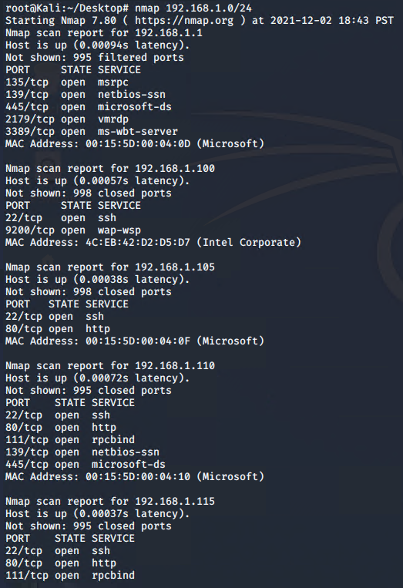

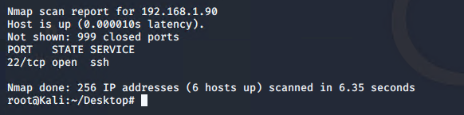

Command: nmap -sV 192.168.1.110

Output:

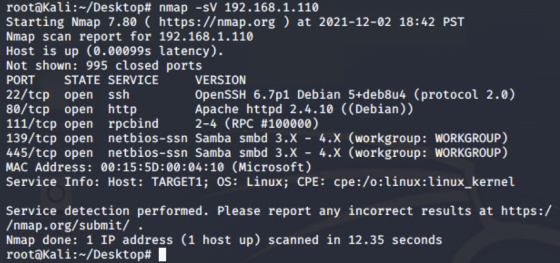

Potential Points of Entry:

Target 1

* Port 22/tcp open
* Port 80/tcp open
* Port 111/tcp open
* Port 139/tcp open
* Port 445/tcp open

Critical Vulnerabilities:

Target 1

* Usernames/password enumeration.
* Accessible SSH access.
* Weak password policy.
* Unsalted passwords.

WP Scan Results:

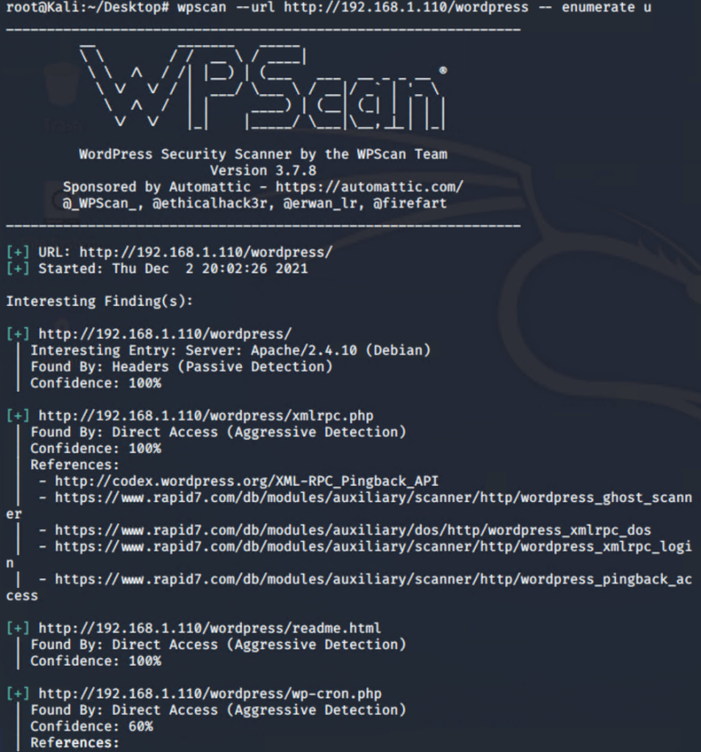 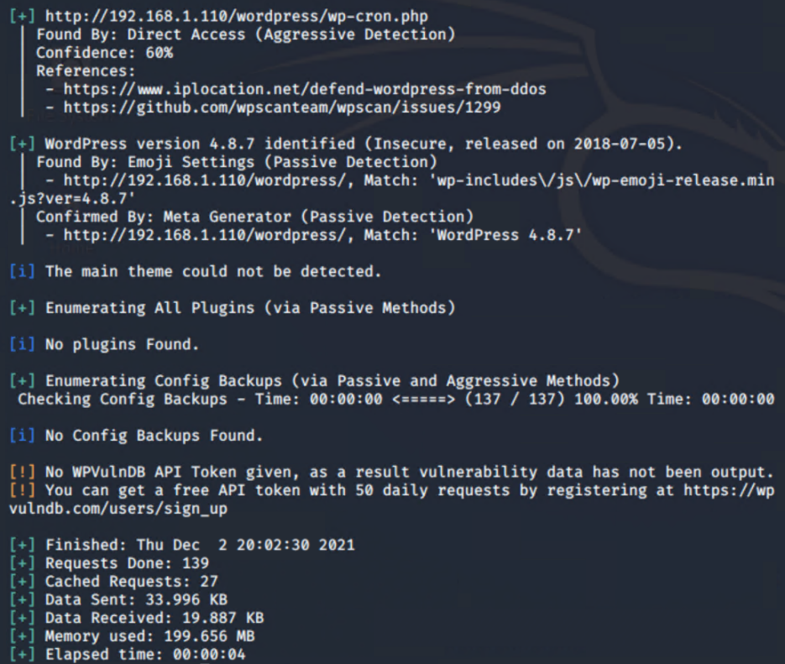

Users Identified:

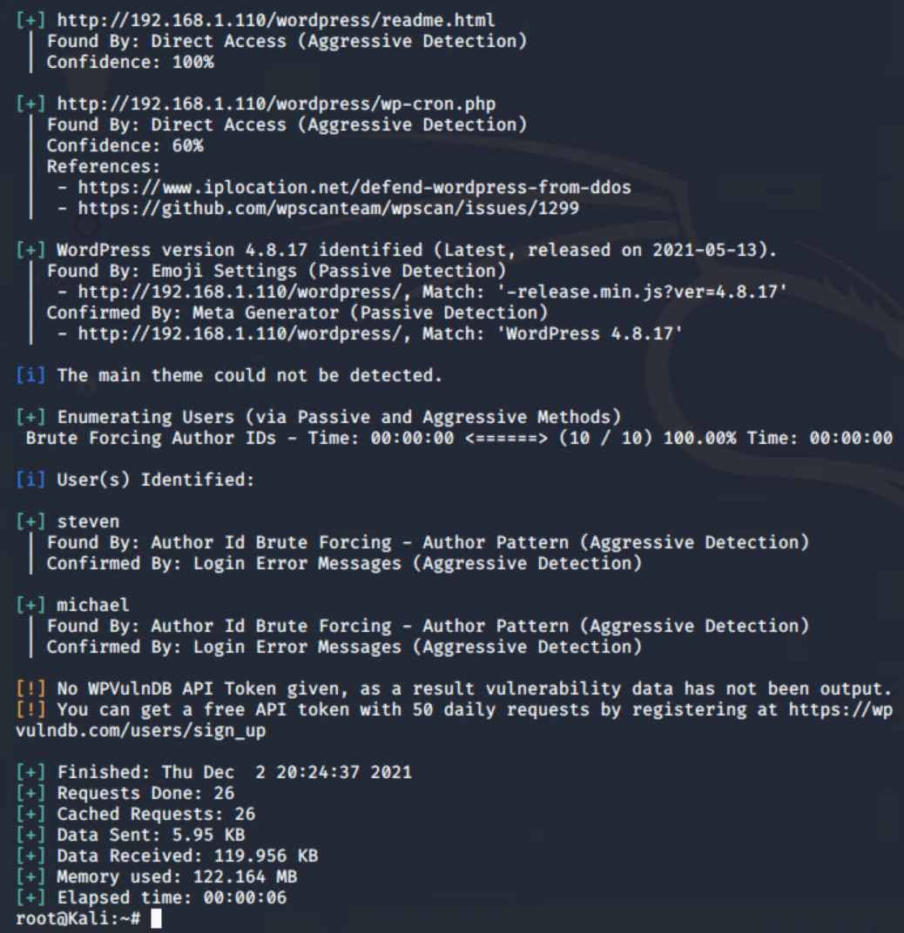

Unhashed Passwords Discovered:

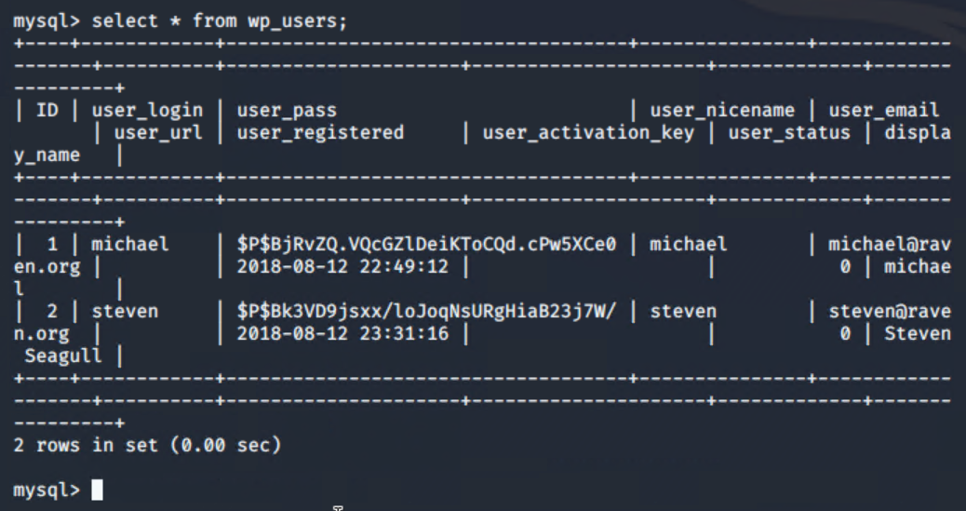

Michaels Password weak (“michael”). Stevens password cracked with John:

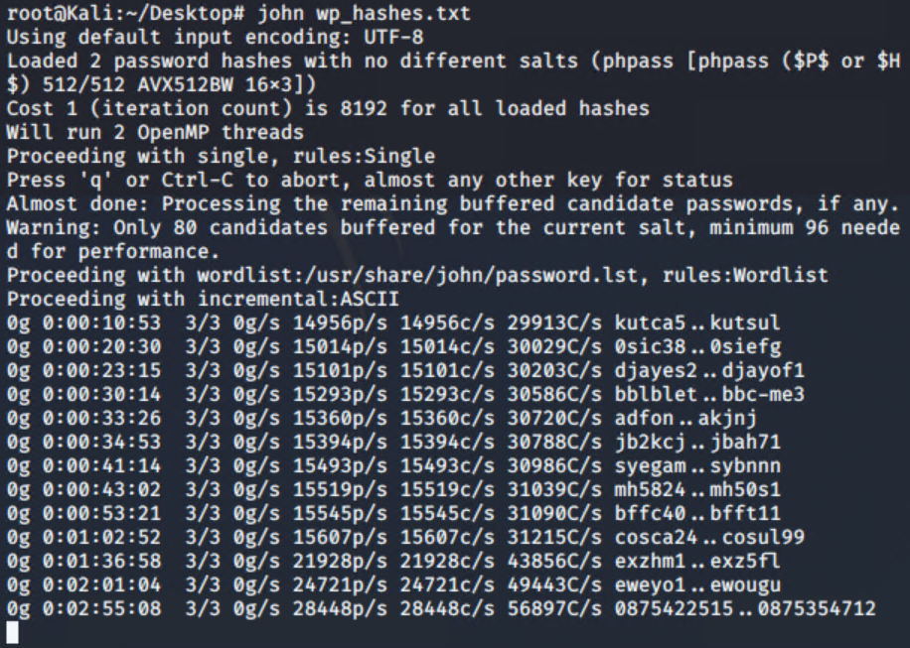

SSH Access through Michael:

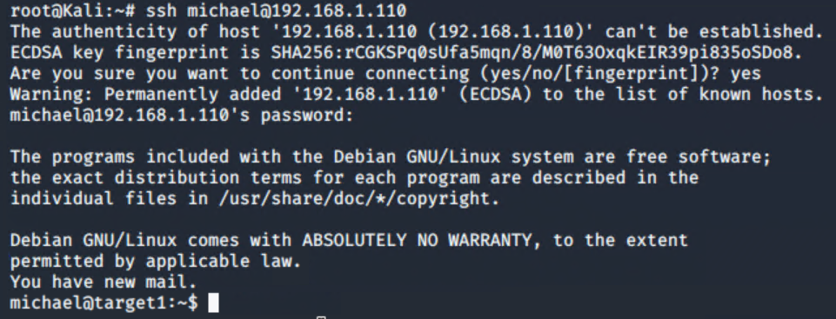

Access to Files/Folders With SSH (Flag 2 Discovered):

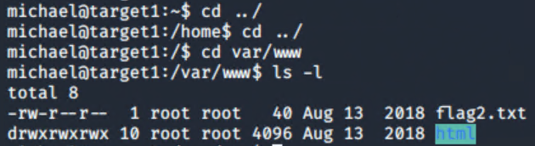

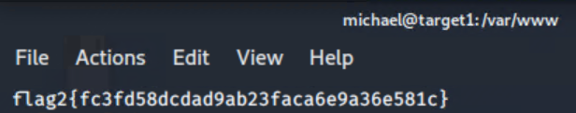

MySQL Access Gained:

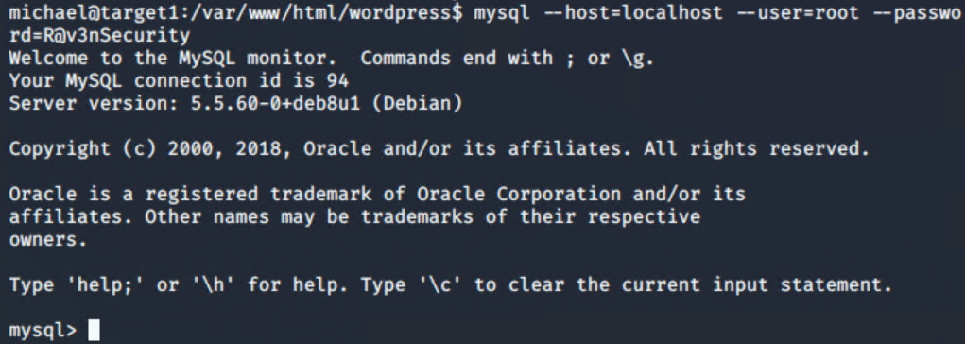

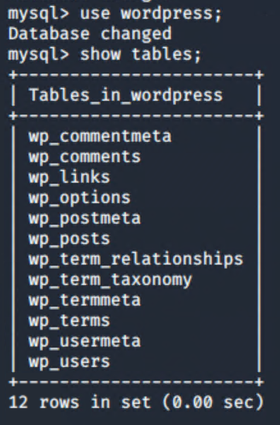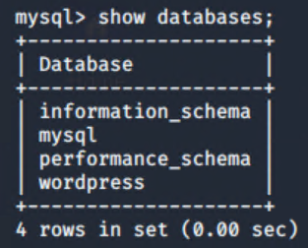

MySQL Posts (Flag 3 and 4 Discovered):

